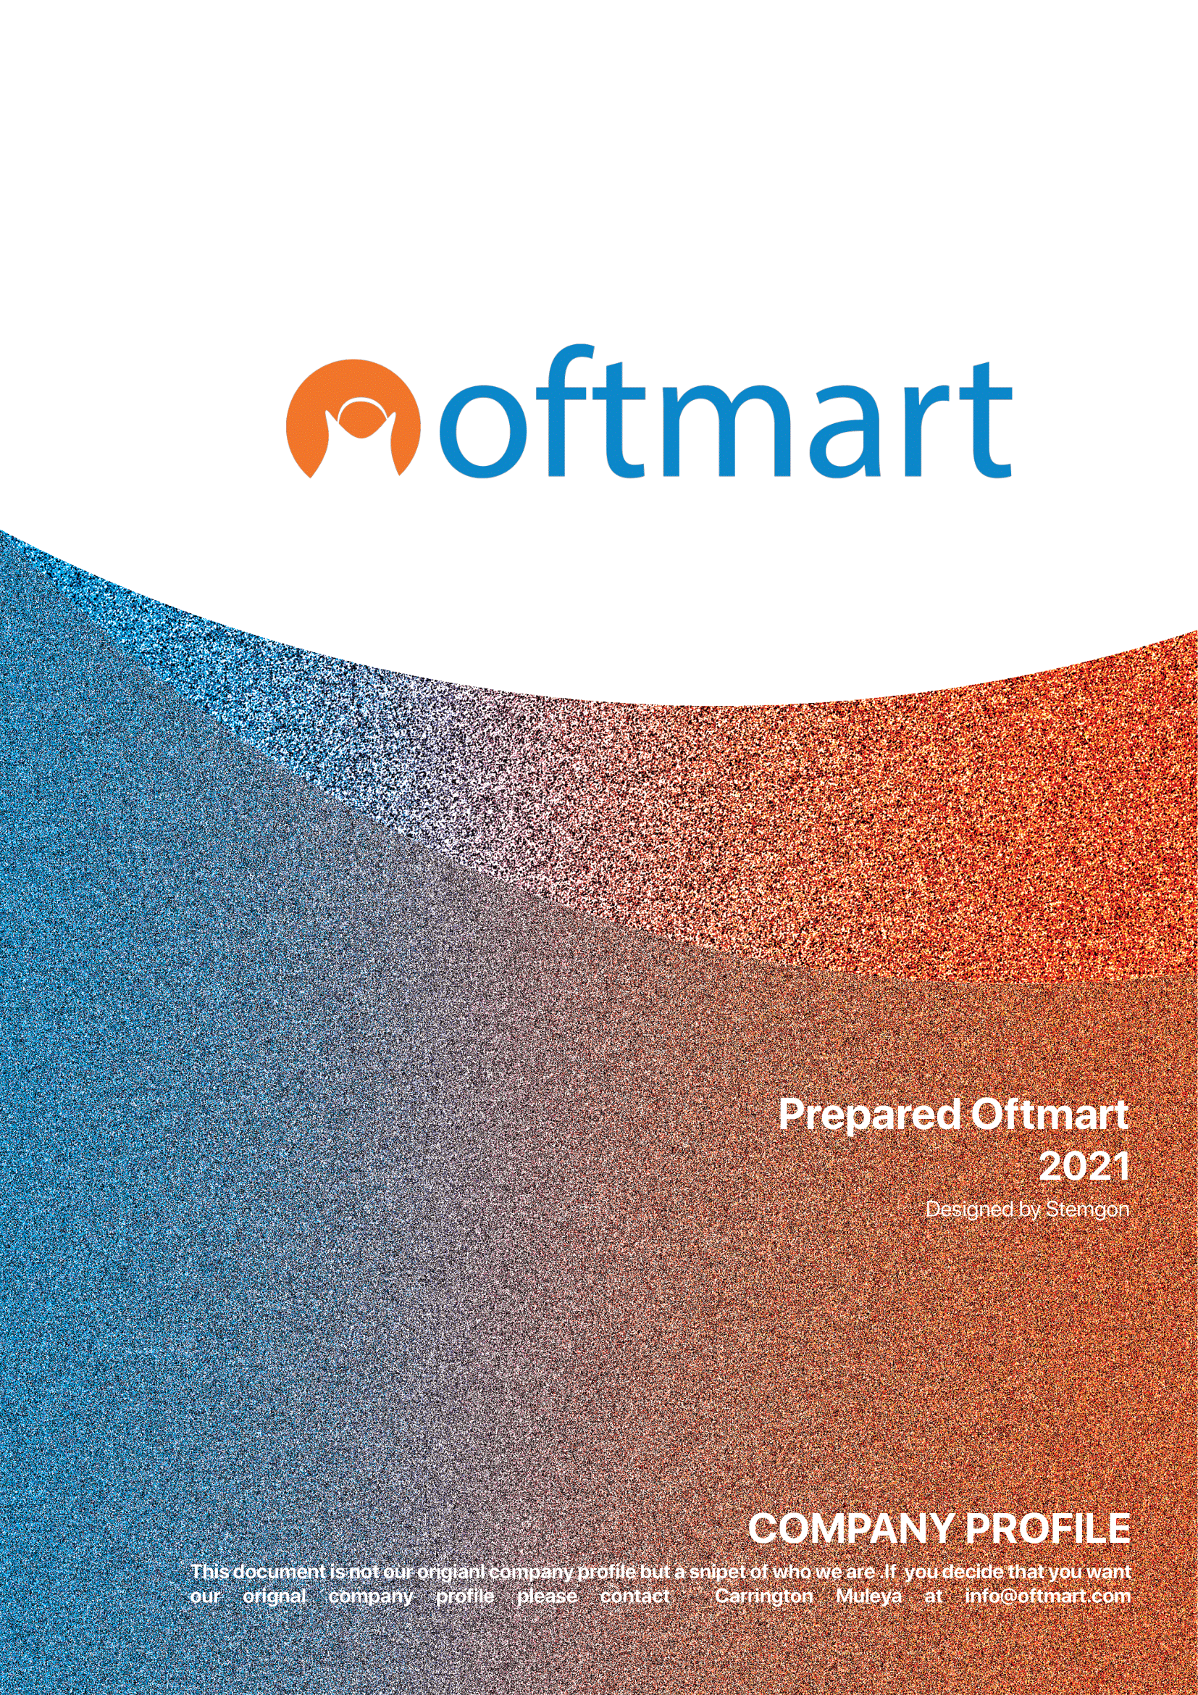

Contents

Introduction 2

About Oftmart 2

Why is Oftmart important in the retailing industry? 2

Suppliers 2

How we operate? 2

Where do we deliver? 3

Shipping fee 3

# Introduction

With the rapid growth in online retailing industry, improved transport systems around the world, and yet hiking of prices for all types of products we believe something can be done to reduce costs, Oftmart was built with aim to address problems such as product availability, affordability, and improvement.

# About Oftmart

Oftmart Pty Ltd is an online retailing store and in premise store started by a young entrepreneur in South Africa. Its aim is to make everything accessible while cutting large queues in shops and while aiming to do away with wholesalers in the supply chain by buying goods straight from the manufacturers where we can.

Oftmart Pty Ltd aims to outsource quality products all around the world and distribute them all around Africa. We also aim to reduce the price of goods by at least a reasonable amount of money. Africans can buy every type of product with us while confident that quality is retained, affordability is taken care of, and availability is mastered.

Oftmart Pty Ltd has partnered with Stemgon Pty Ltd to make sure that all services are delivered to the right people fairly through Oftmart Platform. With this partnership we hope that Oftmart will have an android mobile app and an IOS mobile within a short space of time.

Oftmart is currently working on a mobile application for android and IOS. These applications are expected to speed up shopping and yet accessible and easy to use.

# Why is Oftmart important in the retailing industry?

Oftmart has an online platform that easy to navigate, and which aims to reduce the time it takes for one to shop at Oftmart. Oftmart is also customer centric. With rapid growth of store, there is a correlated growth in customer negligence as well but as Oftmart, we aim to keep our standard despite our surroundings.

We aim to reduce prices of food in South Africa and improve accessibility. C**yber & Data Security.** When it comes to eCommerce, one of the biggest challenges faced is security breaches. There is a lot of information/data that is involved while dealing with eCommerce and a technical issue with data can cause severe damage to the retailer’s daily operations as well as brand image. Oftmart has secure platform that is guided against such.

Online Identity Verification is one of the biggest challenges that Oftmart is addressing. A lot of people claim to be who they are not and to fight this Stemgon has developed some security features. Oftmart continues to solve dozens of problems for the sake of customers.

# Suppliers

Oftmart is in the process of establishing new partnerships across the globe. Currently, we have secured 23 partnerships to receive products from different companies. Our suppliers offer a wide range of products such as cellphones, computers, groceries, furniture etc.

# How we operate?

As Oftmart we operate both online and in premise setup. While we are still growing to huge markets, Oftmart has aim to establish centers where furniture will be available to review. This is seen to be an effective way of interacting with people who still need to prove our authenticity. We deliver our products in South Africa and Zimbabwe. For products in South Africa, we deliver within a week provided the product was on stock when ordered and in Zimbabwe, we deliver within 10 working days. Oftmart wants to expand to other places such as Zambia, Malawi, Kenya and more.

While Oftmart is an online retailing store, we also operate as suppliers to more than 200 stores in South Africa and we are hoping to expand.

# Where do we deliver?

We deliver in South Africa and Zimbabwe.

# Shipping fee

Our shipping fee is dependent on the customer’s location. While only customers buying less than 2500 rands worth of products are the ones eligible for customer fee, customers in Zimbabwe may find themselves paying more due transportation costs.

# Registration

Oftmart was registered in South Africa in 2021. The bank account is from FNB. It is eligible of making online payments.

# Address and Contact

### Our address is:

395 Francis Baard Street.

Arcadia, 0001

Pretoria, Gauteng

### Our Contacts are:

+27 67 735 2242

+27 83 244 8550

info@oftmart.com

support@oftmart.com

# Consideration

**We are considering** LuxDeco.com to be our supplier for modern furniture for a period of 2 years commencing on the date of the agreement.